SCREEN SHOTS
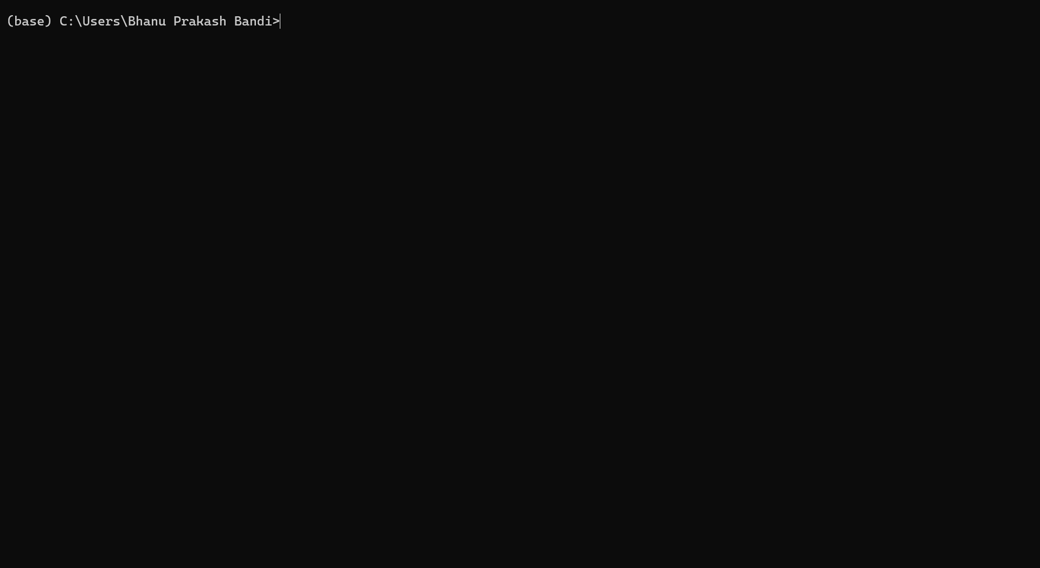
Fig: Anaconda navigator
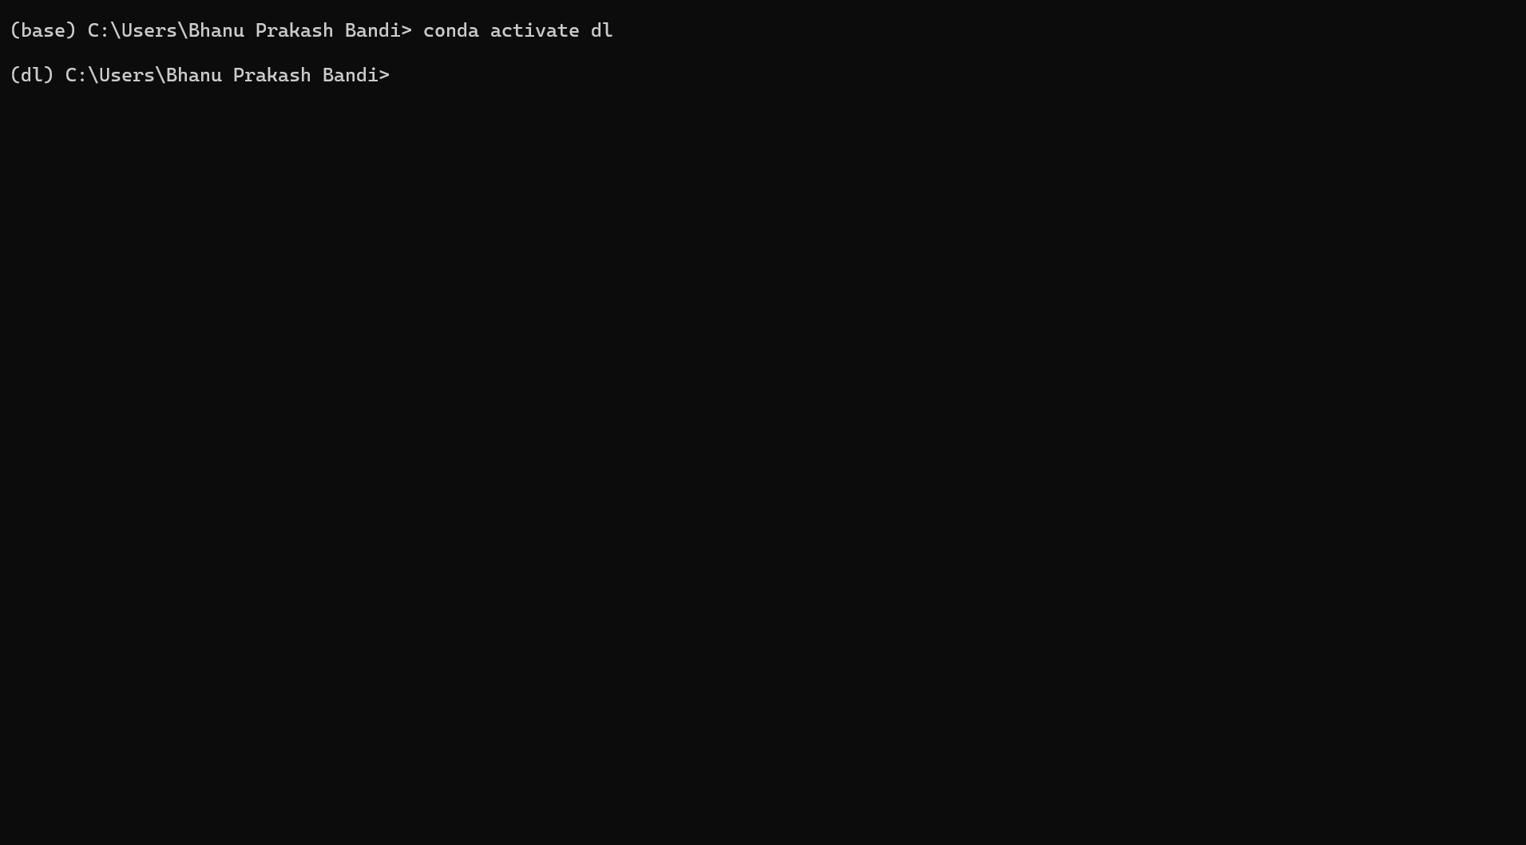
Fig: Creating an Environment
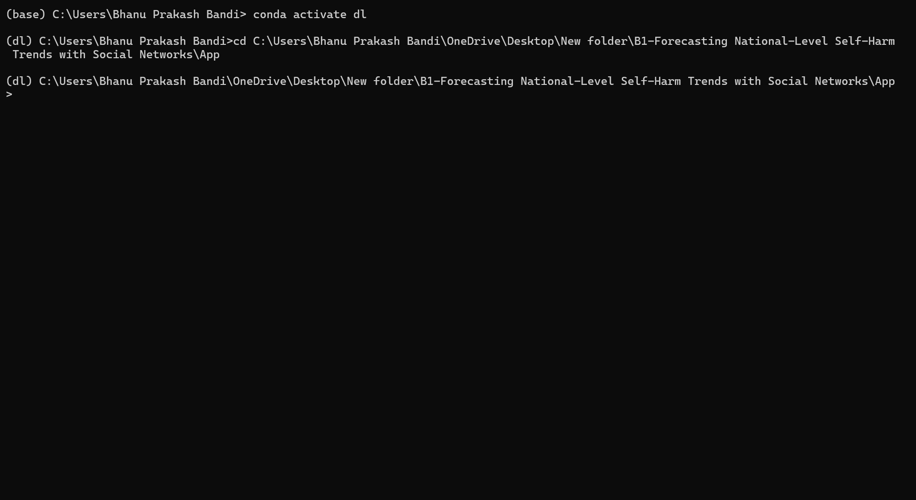
Fig: Entering In to Project Environment
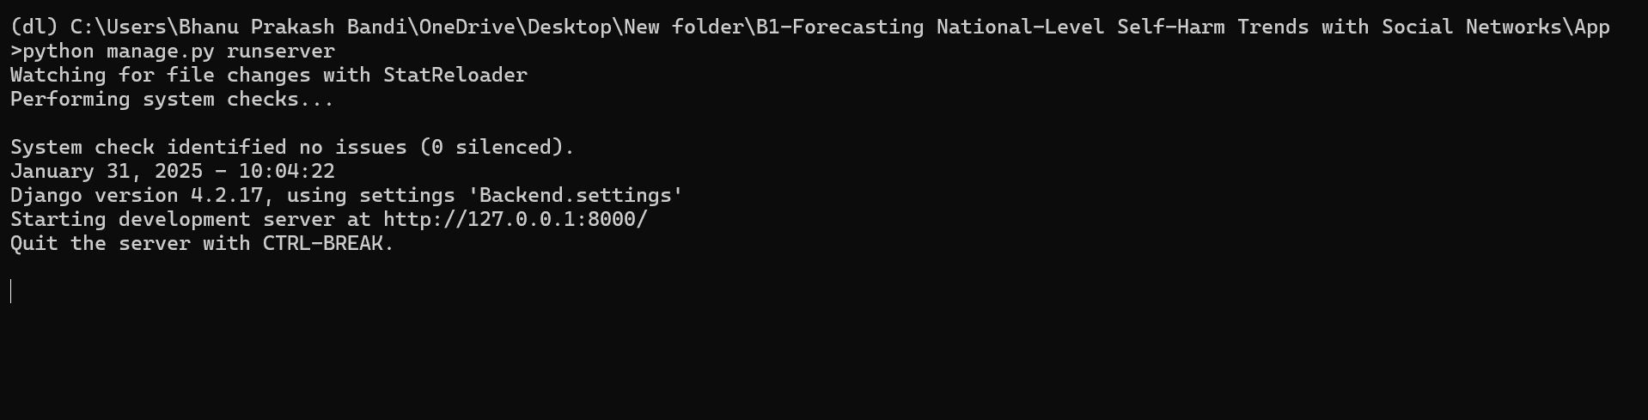
Fig: Running Your Project

Fig: Index Page
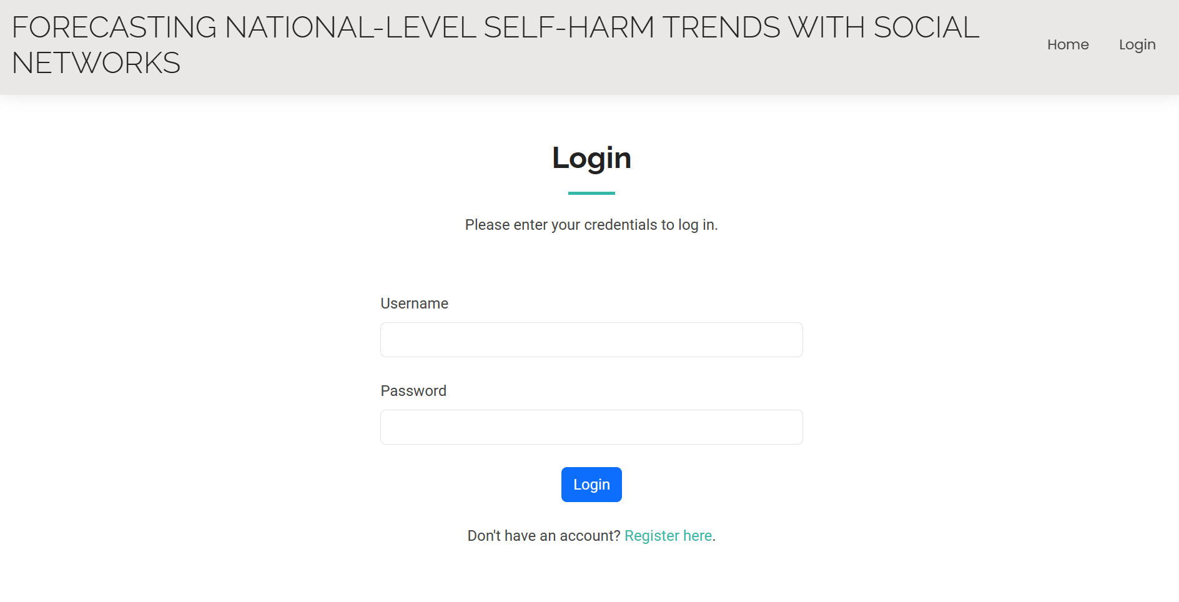
Fig: Login Page Which is used For Both Users and Admin
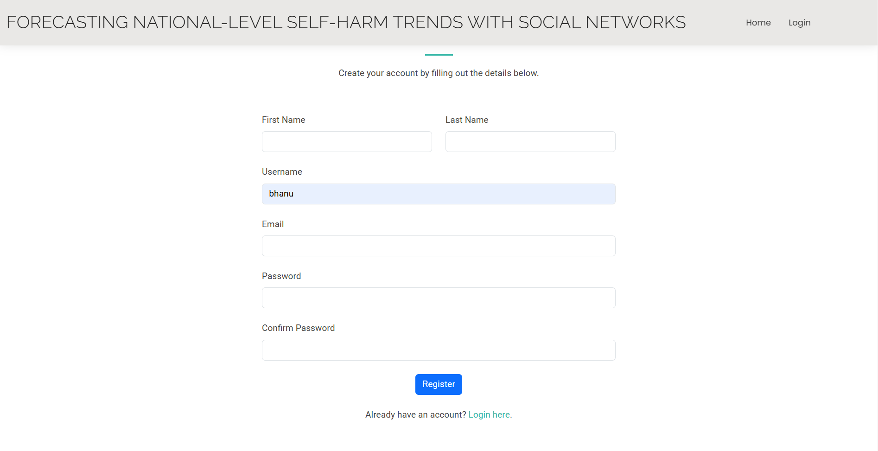
Fig: User Registration Page
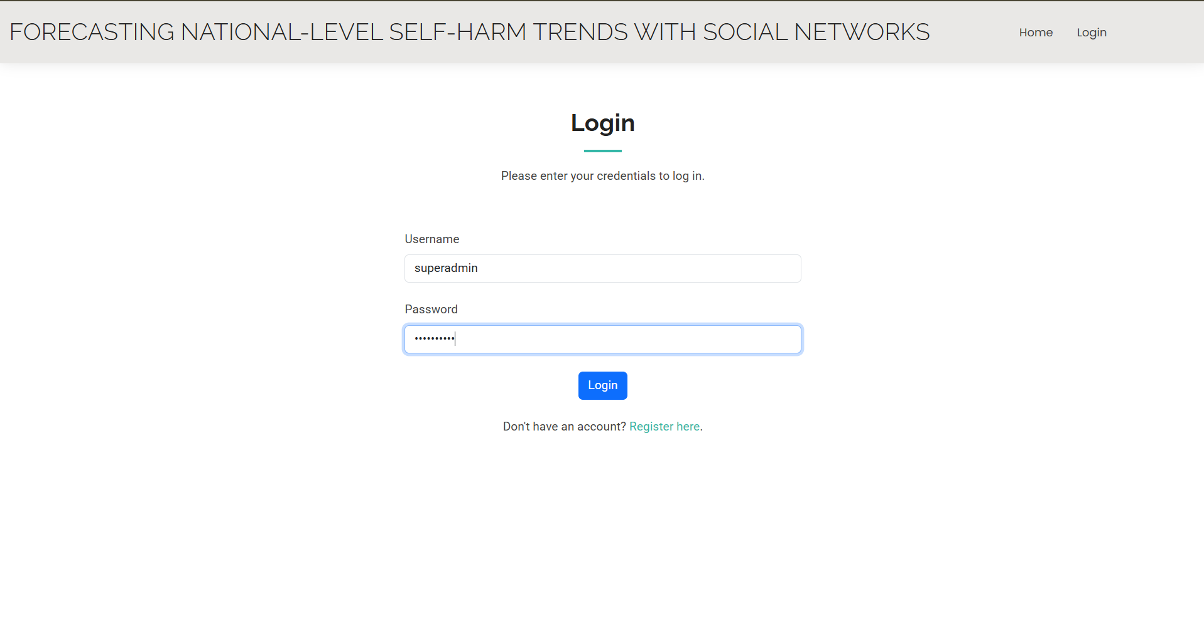
Login Admin Page
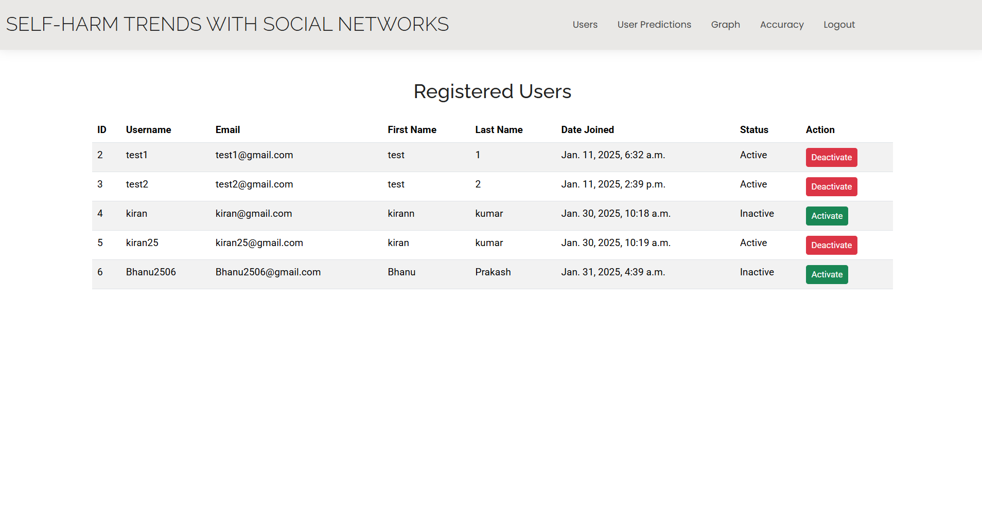
Fig: List Of Users In Admin Page
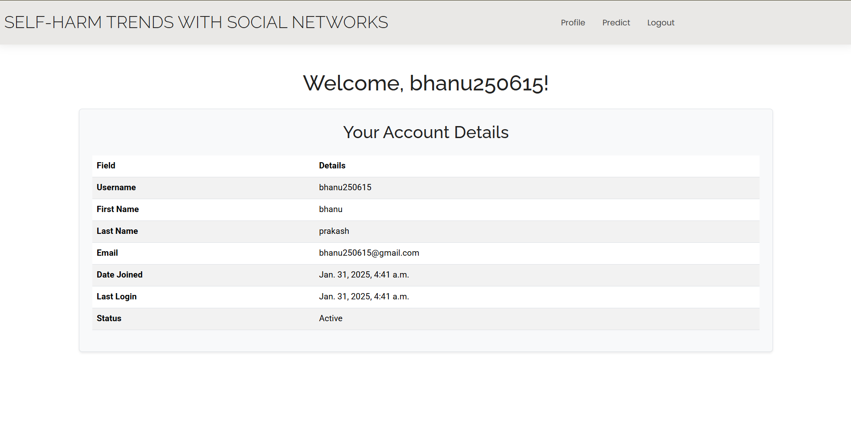
Fig: User Login Page Displaying User Detials
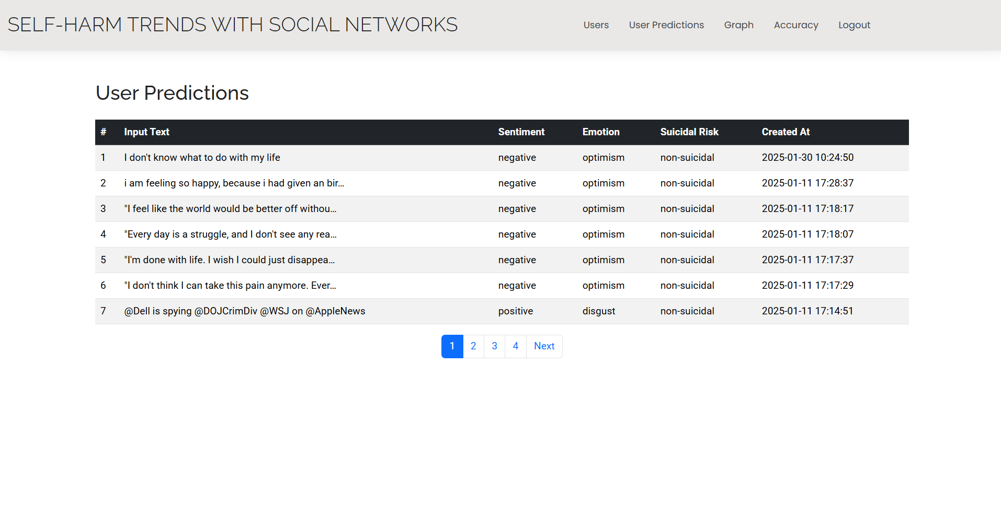
Fig: User Predictions In admin Page
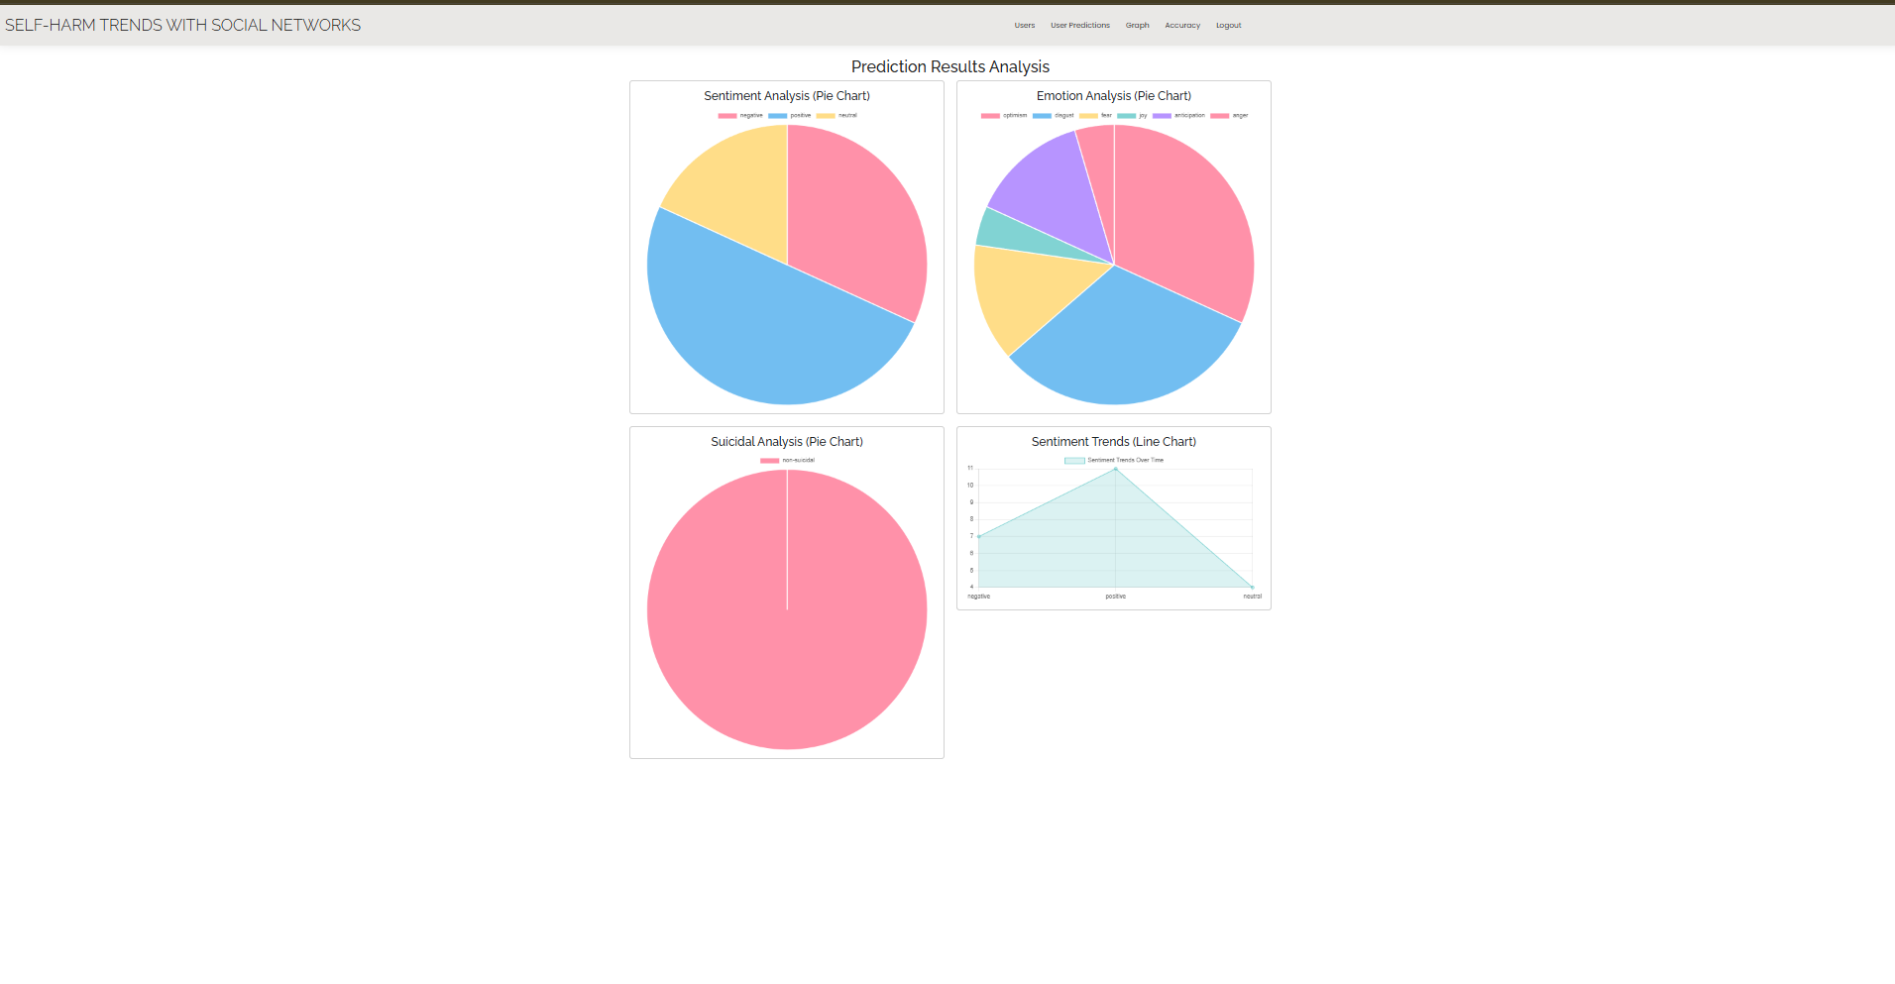
Fig: Prediction Analysis
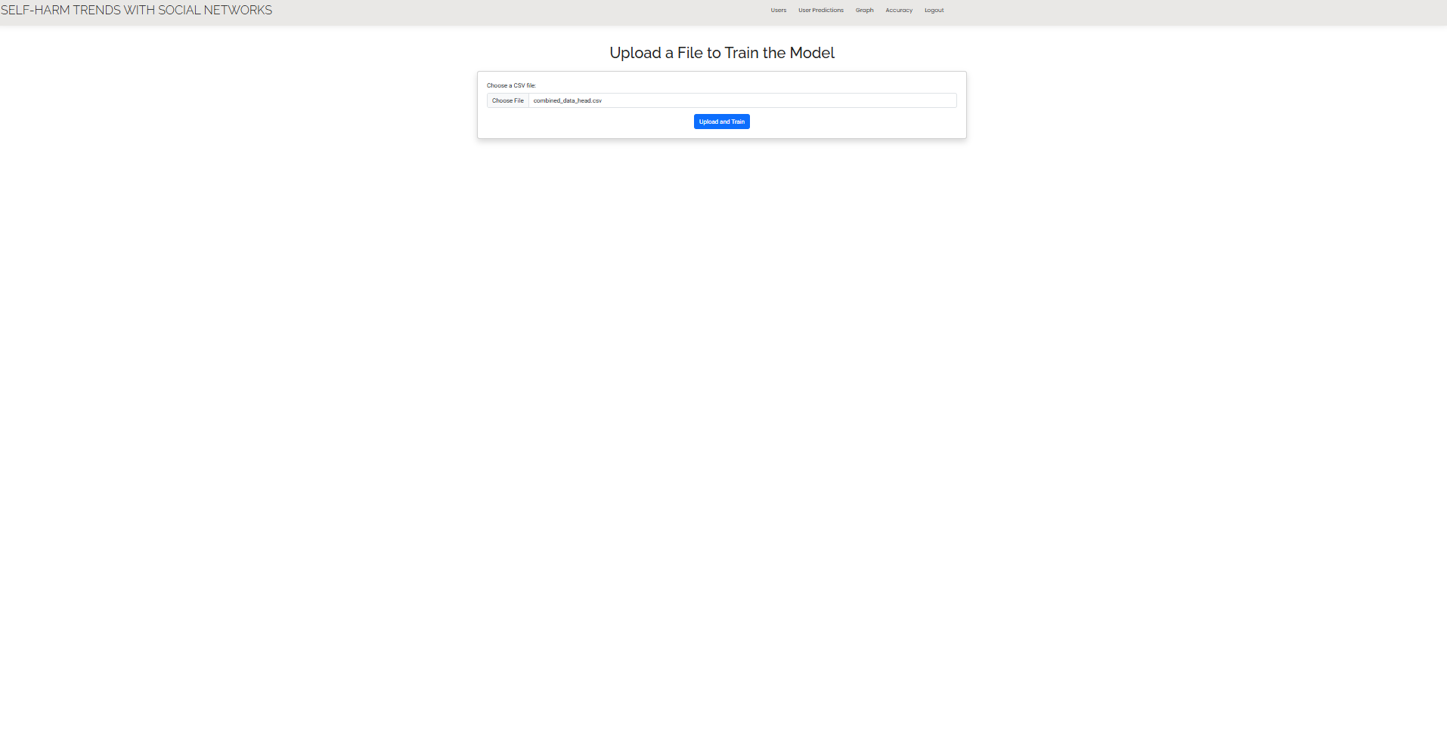
Fig: Uploading Data Set To Train and get accuracy
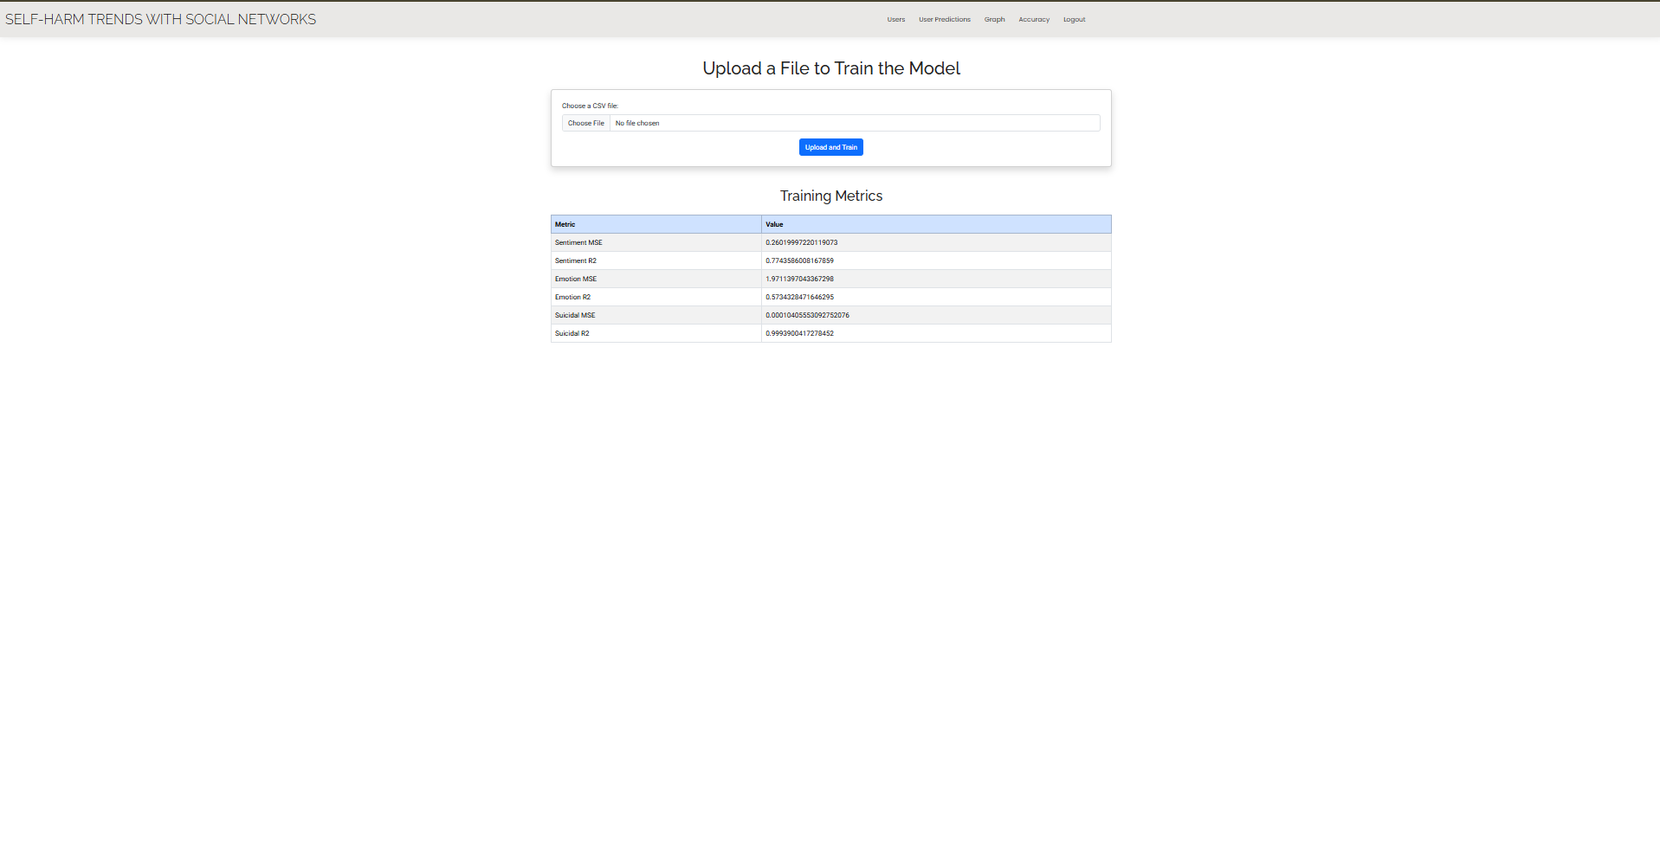
Fig: After training You are getting accuracy values
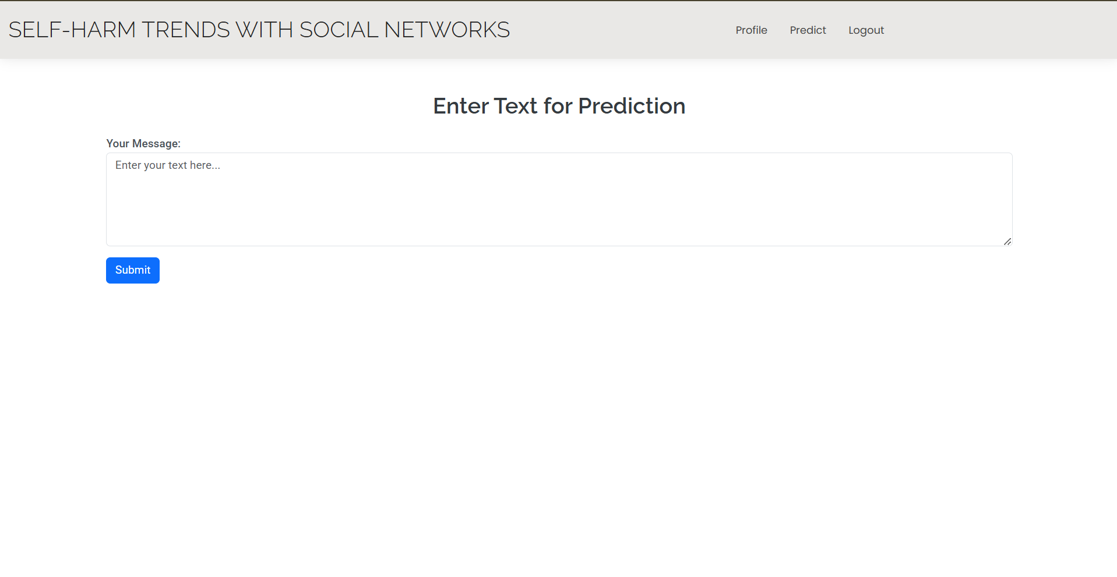
Fig: Displaying User to predict the data
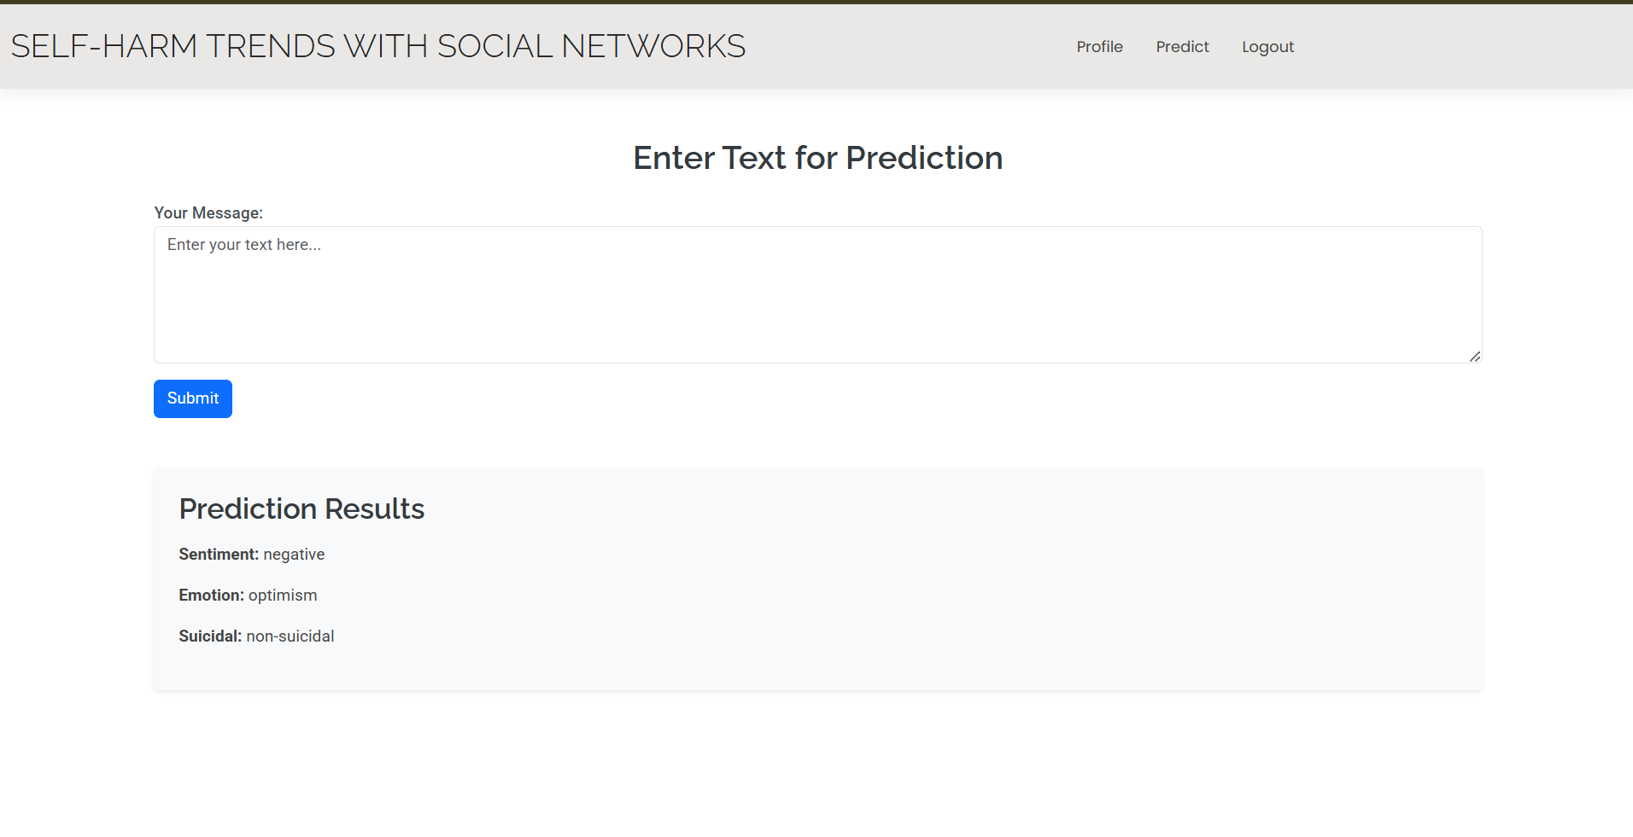
Fig: After Passing Values The Predicted Result we are getting

